**Exciton Diffusion and FRET in Dye-doped Conjugated Polymer Nanoparticles**

Louis C. Groff, Xiaoli Wang, and Jason D. McNeill

**Abstract**

The fluorescence properties of perylene red doped PFBT nanoparticles were investigated by steady state and time-resolved fluorescence spectroscopy. Highly efficient energy transfer at low doping percentages is seen in both the spectra and evidenced in the time-resolved measurements. The time-resolved measurements were simulated using a combined exciton diffusion/energy transfer model coupled with the Poisson statistics. The hypothesis that the reduction in quantum yield of conjugated polymer nanoparticles is due to defects which arise as the nanoparticle forms has been evidenced by the optical properties of both PFBT in good solvent and PFBT nanoparticles. This has also been implemented in the modeling parameters. The results of the exciton diffusion/energy transfer simulations yield an exciton diffusion length of 12 nm for PFBT, which has promising implications for polymer-based photovoltaics.

**Introduction**

**Experimental**

**E.1. Materials.** The copolymer poly[(9,9-dioctylfluorenyl-2,7-diyl)-*co*-(1,4-benzo-{2,1',3}-thiadiazole)] (PFBT, MW 10,000, polydispersity 1.7) was purchased from ADS Dyes, Inc. (Quebec, Canada). The fluorescent dye perylene red (Exalite 613) was purchased from Exciton (Dayton, OH). The fluorescent dye fluorescein was purchased from Invitrogen (Eugene, OR). The solvent tetrahydrofuran (THF, anhydrous, 99.9%) and sodium hydroxide (SigmaUltra, minimum 98%) were purchased from Sigma-Aldrich (Milwaukee, WI). All chemicals were used without further purification.

**E.2. Nanoparticle Preparation.** Preparation of the fluorescent nanoparticles was performed using a previously described reprecipitation method.1 The copolymer PFBT was dissolved in THF by gentle agitation and prepared at a concentration of 1000 ppm. The solution was then further diluted to a concentration of 20 ppm. Perylene red was dissolved in THF by gentle agitation and prepared at a concentration of 100 ppm. The solution was further diluted to 2 ppm for doping. Varying amounts of the dopant perylene red solution were mixed with the PFBT solution to produce solution mixtures with a constant concentration of 20 ppm PFBT and dopant/host fractions of 0 to 2 wt% perylene red. The mixtures were sonicated very briefly to ensure homogeneity. A 2 mL quantity of each solution mixture was added rapidly to 8 mL of deionized water under sonication. THF was removed from the resulting nanoparticle suspensions by partial vacuum evaporation and subsequently vacuum filtered through a glass fibre prefilter to remove larger aggregates and a 0.1 µm PTFE membrane filter. The resulting nanoparticle suspensions are clear (not turbid) and stable for months with no visible signs of aggregation.

**E.3. Characterization Methods.** Size distributions and morphologies of undoped and perylene red doped PFBT nanoparticles were determined by atomic force microscopy (AFM). Samples were prepared by dipcasting a freshly cleaned glass coverslip in a diluted nanoparticle suspension for 40 minutes, then removing the coverslip and allowing it to dry overnight in an enclosed environment. Surface topographies were measured on an Ambios Q250 multimode AFM in non-contact mode.

UV-Vis absorption spectra were collected on a Shimadzu UV2101PC scanning spectrophotometer using 1 cm quartz cuvettes. Fluorescence spectra were collected and quantum yield was measured using a commercial fluorimeter (Quantamaster, Photon Technology International, Inc.) using 1 cm quartz cuvettes. Fluorescence lifetimes were measured using time-correlated single photon counting (TCSPC) spectroscopy. The second harmonic (420 nm) of the output of a mode-locked Ti:Sapphire laser (Coherent Mira 9000, ~100 fs pulses) was used to excite the samples. The output of a fast PIN diode (Thorlabs DET210) monitoring the pulse shape was used as the start pulse for a time-to-amplitude converter (TAC, Canberra Model 2145). The laser output incident on the PIN diode was attenuated until the output voltage of the PIN diode read 200 mV. Nanoparticle fluorescence was collected perpendicular to the excitation source after passing through a 460 nm long pass filter for the undoped nanoparticles. An additional 540 ±10 nm band pass filter was added for the doped samples in order to filter out the emission from perylene red. The emission was detected by a single photon avalanche photodiode (APD, Perkin-Elmer, SPCM-AQR). The output of the APD was used as the stop pulse for the TAC. The excitation pulse was attenuated to maintain a count rate ~6 kHz. The analog signal from the TAC was digitized using a multichannel analyzer (FastComTec, MCA-3A). Before and after each fluorescence lifetime measurement, the instrument response function (IRF) was measured using scattered laser light from a dilute suspension of polystyrene microspheres. The width of the resulting IRF was ~80 ps (FWHM).

**Results and Discussion**

**Initial characterization of dye-doped PFBT CPNs.** Doping of conjugated polymer nanoparticles (CPNs) with dyes is being pursued as a strategy for improving their brightness and photostability while red-shifting their fluorescence, and as a way to investigate exciton diffusion in conjugated polymers. PFBT was selected as the host polymer owing to its excellent photostability and high fluorescence quantum yield, as well as its broad fluorescence spectrum, which facilitates energy transfer to dyes.2 Towards the goal of developing brighter, more photostable nanoparticles, perylene red was selected as the dye dopant for this system due to the excellent spectral overlap with the emission spectrum of PFBT and its high fluorescence quantum yield (0.98 in dichloromethane). Perylene red-doped PFBT CPNs were prepared via a reprecipitation method described previously.1 Samples were filtered through a 0.1 µm membrane filter and characterized via UV-Vis and fluorescence spectroscopy. Size distributions were determined via z-height analysis of representative AFM images (c.f. Fig 1).

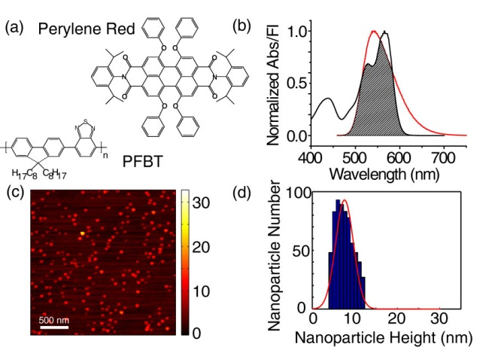

**Fig 1.**  (a) Structures of perylene red and PFBT. (b) Normalized perylene red absorbance (black line) and PFBT fluorescence (red line) in THF with spectral overlap region shaded. (c,d) Representative AFM image of undoped PFBT CPNs and particle size histogram.

Energy transfer efficiency is determined by the ratio of peak donor fluorescence intensities obtained from spectra at various doping percentages, given by

. (1)

Energy transfer as high as 86% is observed with as little as 2% perylene red dopant. The high energy transfer efficiency at low doping ratios is evidence that most of the dye is incorporated in the CPNs, rather than dissolved in the water, as expected, due to the hydrophobic character of the dye. The spectra show that the intensity of acceptor emission in the doped samples increases as dopant is added up to 0.5% doping. Upon further doping, acceptor emission intensity decreases. This is hypothesized to be due to aggregation quenching of the acceptor within the nanoparticle as dye dimers begin to form. This also accounts for the red shift of the acceptor emission as doping increases. Stern-Volmer quenching analysis yields a quenching constant of 37 per molecule, indicating that roughly 37 PFBT molecules are quenched by a single perylene red dye. The quantum yield of undoped PFBT CPNs was measured to be 0.14 using fluorescein in 0.01 M NaOH as a standard, which is consistent with prior measurements.2,3 The total fluorescence quantum yield of the doped samples decreases with increasing perylene red dopant and follows a roughly linear trend. Therefore, doping with perylene red alone does not increase the brightness of PFBT CPNs (c.f. Fig 2). However, at moderate doping levels (0.5%-1%), the decrease in fluorescence quantum yield is not substantial, while the energy transfer efficiency is high.

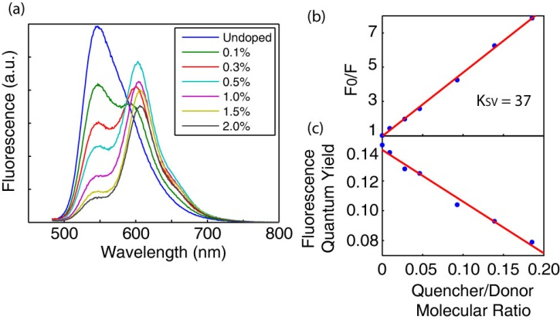

**Fig 2.** (a) Fluorescence spectra of perylene red doped PFBT CPNs at various doping ratios. (b) Stern-Volmer quenching plot. (c) Total fluorescence quantum yield vs. quencher-donor molecular ratio.

**Picosecond time-resolved fluorescence spectroscopy.** A key component to understanding exciton dynamics in CPNs is the measurement of the distribution of exciton lifetimes. Time-correlated single photon counting (TCSPC) is an invaluable method for determining lifetimes on the sub-nanosecond time scale. The apparatus employed is described in the previous section. The resulting decay trace is fit by a least-squares minimization procedure involving convolution of a trial decay function with the instrument response function. The trial functions are (single) exponential

, (2)

bi-exponential

, (3)

and the stretched exponential or Kohlrausch-Williams-Watts (KWW) function,

. (4)

The KWW function includes a stretch-parameter ß, which acts as a measure of lifetime heterogeneity, ranging between ~0.2 and 1, where lower values indicate a broad distribution of lifetimes while ß = 1 corresponds to a single exponential.4The fluorescence decay of PFBT in THF fit well to a single exponential, while the decays of undoped nanoparticles and lightly to moderately-doped particles (0.1%-1.0%) exhibited complex decay kinetics that fit well to both bi-exponential and stretched exponential (KWW) functions. While single exponential fits converged for all samples, bi-exponential and KWW fits did not converge for 1.5% and 2% doping due to low signal levels and short lifetimes. Results show a decreasing trend in lifetimes with a slight decreasing trend in beta (c.f. Fig 3). The decreasing trend in beta corresponds to increasing heterogeneity, or a broader distribution of exciton lifetimes as doping increases. The observed increase in heterogeneity agrees qualitatively with the physical picture of exciton diffusion and energy transfer, which will be discussed below.

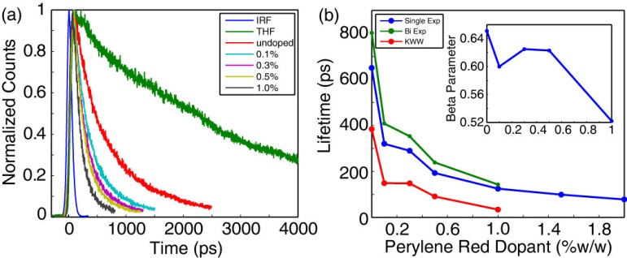

**Fig 3.** (a) Normalized fluorescence lifetime decay traces for PFBT in THF and doped CPNs. (b) Single exponential (blue), bi-exponential weighted average (green), and KWW (red) lifetimes of perylene red doped CPNs. Inset: KWW heterogeneity parameter ß vs. perylene red dopant percent.

**Exciton Diffusion Energy Transfer Model.** A number of experimental observations as well as arguments based on theoretical considerations appear to indicate that excitons in conjugated polymers can hop from chromophore to chromophore in a random, diffusion-like process prior to decaying or undergoing energy transfer to a defect or dopant molecule.5,6,7 The dynamics of these processes can be modeled by way of a random walk algorithm, yielding predicted values for energy transfer efficiency.8 We have recently extended the simulation code to provide the distribution of exciton lifetimes. By comparing the simulation results to experimental results for energy transfer efficiency and fluorescence lifetime, it is possible to determine values such as the exciton diffusion length

, (5)

where n is the dimensionality (n = 3), D is the exciton diffusion constant and is the fluorescence lifetime of the polymer in good solvent.

It is hypothesized that quenching by defects in the polymer occurs upon nanoparticle formation in undoped CPNs, as evidenced by three main observations. First, the quantum yield and excited state lifetime of the nanoparticles is greatly reduced ( = 0.14,  = 800 ps) as compared to PFBT in THF ( = 0.66,  = 3000 ps). Secondly, the heterogeneity of the excited state lifetime of the nanoparticle is increased (ß = 0.65) as compared to the free polymer in solution (ß = 1.0). Lastly, the reduction in radiative rate of the nanoparticles (1.8x108 s-1) is not substantial compared to the polymer in THF (2.2x108 s-1), which rules out dipole-coupling in aggregates as the principal cause of the change in lifetime, and thus favors the defect quenching hypothesis. In order to account for this hypothesis in the simulation, the average number of defects per nanoparticle (expressed in dye equivalents) has been added as a model parameter (c.f. Fig 4).

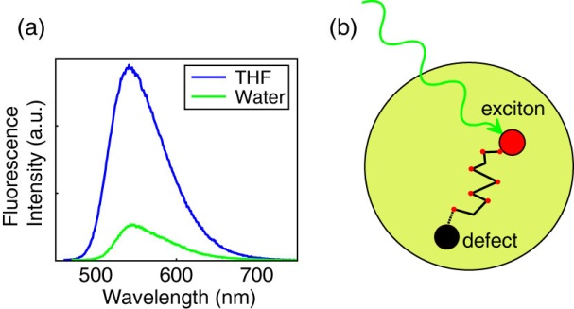

**Fig. 4.** (a) Fluorescence spectra of PFBT in THF and undoped PFBT CPNs at 0.1 absorbance. (b) Illustration of energy migration to a defect in a CPN.

Preliminary simulation results (not shown) indicate that the use of the random walk algorithm alone (with no defect quenching) was found to be insufficient to adequately match experimental lifetimes and beta values of perylene red doped PFBT CPNs. In order to better match simulated results to experiment, the Poisson distribution of defects dyes has also been implemented into the model. This is accomplished by calculating the probabilities of a series of dyes and defects being present within the nanoparticle

 (6)

Where  is an integer value of dyes or defects per nanoparticle and  is the mean number of dyes or defects per nanoparticle. The total probability for a given dye/defect pair is calculated by the product of the dye and defect probabilities

. (7)

The resulting data from the exciton diffusion simulations was interpolated and utilized to calculate the Poisson distributed quenching efficiency, lifetime, and beta. These were determined for each dye/defect combination by summing  and using the interpolated simulation data at a value of (+1), multiplied by Equation 7. The overall quenching efficiency was then determined by summing over all possible . The lifetime and beta were utilized with Equations 4 and 7 to generate a Poisson distributed decay trace for a said defect/dye combination. Each resulting decay was summed with the previous traces and the overall summed Poisson decay trace was fit by nonlinear least squares minimization to Equations 3 and 4. Then, the results of the corresponding fits were compared to experimental TCSPC results.

The initial exciton diffusion simulations were carried out for a particle of radius 4 nm, as was determined by AFM (c.f. Fig 1), the exciton diffusion length was set at 12 nm and the time step was set to 1 ps. Initially, a Förster radius of 3 nm was determined from the spectra of perylene red and PFBT in THF using standard methods.9 However, the resulting Poisson decays calculated from the interpolated exciton diffusion data did not match experimental quenching efficiencies very well. Given that there is some uncertainty in the exact quantity of  in the Forster radius calculation:

  (8)

it was hypothesized that the quantity of 3 nm for R0 has some room for minor alteration as a simulation parameter due to uncertainty as to whether or not , a question that will be addressed in future experiments. Thus, simulations were carried out using an increased R0 of 4 nm. The results of which are shown in Fig. 5.

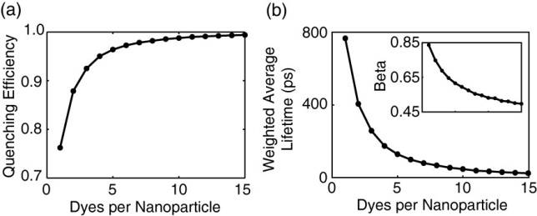

**Fig. 5.** Results of exciton diffusion simulations with an exciton diffusion length of 12 nm, Förster radius of 4 nm, and a particle radius of 4 nm. (a) Quenching efficiency, (b) weighted average lifetime, and beta (inset) vs. number of dyes per nanoparticle.

For the Poisson decays, the number of defects per nanoparticle was calculated by setting  to zero and increasing  until the experimental quenching efficiency of the defects introduced by nanoparticle formation is matched, which is calculated by

, (9)

which is ~0.79 for PFBT. This corresponds to the first data point in Fig. 6. The values for  are calculated by determining the number of PFBT molecules per nanoparticle (~16 molecules per nanoparticle) and multiplying by the quencher/donor molecular ratio

, (10)

where V, C and MW are the volumes, concentrations and molecular weights of the quencher/donor, respectively. The results of the Poisson distributed fluorescence decays are given in Fig. 6.

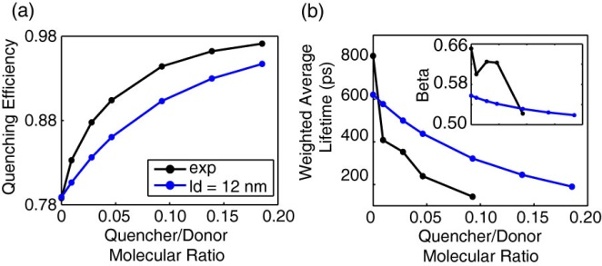

**Fig. 6.** (a) Poisson distributed quenching efficiency and (b) weighted average lifetime and beta (inset) obtained from fitting results of Poisson distributed fluorescence decays. The Poisson distributed results calculated from exciton diffusion data (blue) are compared to TCSPC results (black).

It was determined by matching the quenching efficiency to Equation 9 that the average number of defects introduced into the nanoparticle upon formation is equal to 2.3 perylene red dye equivalents. By introducing the Poisson distribution of defects and dyes, there is a trade-off in the accuracy in fit to quenching efficiency for greater accuracy in lifetimes and beta. Nevertheless, the simulated data fits reasonably well to all parameters. While the exciton diffusion length of 12 nm is similar to that obtained for polyfluorene films using similar methods,10 it contrasts dramatically with other reports in the literature of exciton diffusion lengths of organic semiconductors on the order of 100 nm,11 or even as high as 2.5 µm,12 providing additional evidence that reports of such large exciton diffusion lengths are erroneous.13 This result has implications for polymer-based photovoltaics, since the exciton diffusion length is roughly a factor of ~4 lower than the optical skin depth of the polymer.

**Conclusions**

Perylene red doped PFBT CPNs were prepared by reprecipitation, and undergo efficient energy transfer from PFBT to perylene red at low doping percentages. The fluorescence characteristics of the dye doped CPNs were studied by steady state and time-resolved fluorescence methods. The spectra are red-shifted significantly with only minor losses in fluorescence quantum yield. The lifetimes of the nanoparticle samples are reduced as doping increases. The distribution of exciton lifetimes was measured to increase as doping increases, as evidenced by a decreasing trend in KWW beta parameter. A combined exciton diffusion/energy transfer model coupled with Poisson statistics was utilized to determine the exciton diffusion length of 12 nm for PFBT CPNs with the assumption that the Förster radius is 4 nm, instead of the 3 nm value determined from spectra due to uncertainty in . These results could prove useful for polymer-based photovoltaic applications.

(1) Szymanski, C., Wu, C. F., Hooper, J., Salazar, M. A., Perdomo, A., Dukes, A., and McNeill, J. *Journal of Physical Chemistry B* **2005**, *109*, 8543.

(2) Wu, C. F.; Bull, B.; Szymanski, C.; Christensen, K.; McNeill, J. *ACS Nano* **2008**, *2*, 2415.

(3) Tian, Z., Yu, J., Wu, C. F., Szymanski, C. and McNeill, J. *Nanoscale* **2010**, *2*, 1999.

(4) Chen, R. *Journal of Luminescence* **2003**, *102*, 510.

(5) Tvingstedt, K., Vandewal, K., Zhang, F., and Inganäs, O. *Journal of Physical Chemistry C* **2010**, *114*, 21824.

(6) Simas, E. R., Gehlen, M. H., Pinto, M. F. S., Siquiera, J., and Misoguti, L. *Journal of Physical Chemistry A* **2010**, *114*, 12384.

(7) Dykstra, T. E., Hennebicq, E., Beljonne, D., Gierschner, J., Claudio, G., Bittner, E. R., Knoester, J., and Scholes, G. D. *Journal of Physical Chemistry B* **2009**, *113*, 656.

(8) Wu, C. F., Zheng, Y. L., Szymanski, C., and McNeill, J. *Journal of Physical Chemistry C* **2008**, *112*, 1772.

(9) Lakowicz, J. R. *Principles of Fluorescence Spectroscopy*; Third ed.; Springer Science+Business Media, LLC: New York, 2006.

(10) Lyons, B. P., and Monkman, A. P. *Physical Review B* **2005**, *71*, 235201.

(11) Reid, P. J., Higgins, D. A. and Barbara, P. F. *Journal of Physical Chemistry* **1996**, *100*, 3892.

(12) Gregg, B. A., Sprague, J. and Peterson, M. W. *Journal of Physical Chemistry B* **1997**, *101*, 5362.

(13) Lunt, R. R., Giebink, N. C., Belak, A. A., Benzinger, J. B., and Forrest, S. R. *Journal of Applied Physics* **2009**, *105*, 053711.